**A**

**Project Report**

**On**

**TETRIS GAME**

**Submitted by**

***Raghav Mahajan 2205101100103***

***Dipesh Rauniyar 2205101100152***

***Kunal Yadav 2205101100157***

**as**

**Partial fulfilment of Semester V**

**of Bachelors of Computer Applications/ Bachelor of Science in Information Technology (select your course)**

**for A.Y. 2024-2025**

**Under the Guidance of**

**Internal Guide name: Prof. Saswati Chatterjee**

**External Guide name:**

**Submitted To**

**Parul Institute of Computer Application,**

**Faculty of IT & Computer Science**

**Parul University**



**Acknowledgement**

*The success and final outcome of this project required a lot of guidance and assistance from many people and we are extremely privileged to have got this all along the completion of our project. All that we have done is only due to such supervision and assistance and we would not forget to thank them.*

*I respect and thank Dr. Priya Swaminarayan, Dean, FITCS for providing us an opportunity to do the project work in BCA and giving us all support and guidance which made us complete the project duly. We are extremely thankful to Mam for providing her support and guidance, although she had a busy schedule managing the academic affairs.*

*We would not forget to remember Prof. Hina Chokshi, HOD, BCA department for her encouragement and more over for her timely support and guidance till the completion of our project work.*

*We owe our deep gratitude to our project guide Dr./****Prof. Saswati Chatterjee*** *who took keen interest on our project work and guided us all along, till the completion of our project work by providing all the necessary information for developing a good system.*

*I am thankful to and fortunate enough to get constant encouragement, support and guidance from our Parents, all Teaching staff of the BCA Department which helped us in successfully completing our project work. Also, we would like to extend our sincere esteems to all staff in the laboratory for their timely support.*

***Raghav Mahajan 2205101100103***

***Dipesh Rauniyar 2205101100152***

***Kunal Yadav 2205101100157***



**PARUL INSTITUTE OF COMPUTER APPLICATION**

**CERTIFICATE**

This is to certify that ***__Raghav Mahajan, Dipesh Rauniyar , Kunal Yadav*** the student(s) of Parul Institute of Computer Application, has/have satisfactorily completed the project entitled “***Tetris Game”*** as a part of course curriculum in BCA / BSCIT/ IMCA semester- V for the academic year 2024-2025 under guidance of ***_Prof.Saswati Chatterjee.***

Enrolment Number: 2205101100103

Enrolment Number: 2205101100152

Enrolment Number: 2205101100157

|  |  |  |
| --- | --- | --- |
| **Quality of work** | **Grade** | **Sign of Internal guide** |
| **Poor / Average / Good /Excellent** | **B /B+ / A / A+** |  |

Date of submission:

HOD, Principal,

Prof. Hina Chokshi Dr. Priya Swaminarayan

**INDEX**

|  |
| --- |
| **Content** **Page No.** |
| 1. Introduction to Project System 2 |
| 1. System Requirement Specification 3 |
| * 1. Introduction to SRS 4 |
| * 1. Hardware Requirement 5 |
| * 1. Software Requirement 6 |
| * 1. System Users 7 |
| * 1. Description of User Role 8 |
| * 1. System Modules 9 |
| * 1. Description of Modules 10 |
| * 1. Timeline Chart 11 |
| 1. System Flow Diagram 12 |
| 1. Data Dictionary 13 |
| 1. Data Flow Diagram (All Levels of DFDs) 14 |
| 1. Use Case Diagram 15 |
| 1. Class Diagram 16 |
| 1. ER Diagram 17 |
| 1. Screenshots of Development Phase -1 18 |
| 1. Screenshots of Development Phase -2 |
| 1. Screenshots of Development Phase -3 |
| 1. Conclusion |
| 1. Future Enhancement |
| 1. References |

**ABSTRACT**

Interpretation of the classic Tetris game, leveraging contemporary game development technologies and design principles. Tetris, originally conceived as a simple yet challenging puzzle This project aims to develop a modern game, has evolved into a cultural phenomenon since its inception. The objective of this project is to honor its legacy while introducing new features and enhancements that cater to today’s gaming audience. The game offers multiple levels of difficulty, word categories, and game modes to cater to the diverse needs and preferences of the users. The game's hint system, high score tracking, and user profiles provide motivation and feedback to the users, keeping them engaged and challenged.

1.Introduction to Project System

The Tetris Game project, developed using Python, replicates the classic Tetris game, a popular tile-matching puzzle. The game involves arranging falling tetrominoes to form complete horizontal lines without gaps, which then disappear to earn points.

This project aims to provide a hands-on experience in game development, focusing on implementing core Tetris mechanics such as piece movement, rotation, and line clearing. Utilizing the Pygame library, the project delivers an interactive and visually appealing user interface. This endeavor not only enhances programming and problem-solving skills but also deepens understanding of game development principles.

The Tetris Game project, developed using Python, replicates the classic Tetris game, a popular tile-matching puzzle. The game involves arranging falling tetrominoes to form complete horizontal lines without gaps, which then disappear to earn points. This project aims to provide a hands-on experience in game development, focusing on implementing core Tetris mechanics such as piece movement, rotation, and line clearing.

Utilizing the Pygame library, the project delivers an interactive and visually appealing user interface. This endeavor not only enhances programming and problem-solving skills but also deepens understanding of game development principles.

**2.System Requirement Specification**

**2.1Introduction To SRS**

**2.1.1 What is SRS?**

A software requirements specification (SRS) is a description of a software system to be developed. It lays out functional and non-functional requirements, and may include a set of use cases that describe user interactions that the software must provide.

**2.1.2 Need of SRS**

In order to fully understand one’s project, it is very important that they come up with a SRS listing out their requirements, how are they going to meet it and how will they complete the project. It helps the team to save upon their time as they are able to comprehend how are going to go about the project. Doing this also enables the team to find out about the limitations and risks early on**.**

**2.2 Hardware Requirements**

|  |  |
| --- | --- |
| **Name of Components** | **Specification** |
| Processor | Intel core i3, /i5 |
| RAM | 4GB/8GB |
| Hard Disk | 512GB/1TB |

**2.3 Software Requirements**

|  |  |
| --- | --- |
| **Name of Components** | **Specification** |
| Operating System | Windows 10 |
| Software development tool | Vs Code |
| Tools & languages | SQLite, Python |

**2.4 System Users**

**2.5 Description of User Role**

**2.5.1 Player /User**

Player are the only user of this system .They simply register themselves in system and use the entered username and password to start playing the game. To play they use mouse to select the shown option or letters to guess the words.

**2.6 System Modules**

* Game Engine Module
* Game Board Module
* Input Handling Module
* Scoring and Progression Module
* User Interface (UI) Module
* Sound and Music Module

**2.7Description of Modules**

### ****1. Game Engine Module**:** Manages the overall game logic, including game state and transitions.

**2.Game Board Module:** Represents and manages the Tetris grid where tetrominoes are placed.

**3.Input Handling Module:** Processes user inputs and translates them into game actions.

**4.Scoring and Progression Module:** • Manages scoring and game progression.

**5.User Interface (UI) Module:** Provides visual feedback and controls to the player.

**6.Sound and Music Module:** Enhances the gaming experience with audio effects and music.

**2.8 Timeline Chart**

* 1. **Time Line Chart**

| **Development phase** | ***75 Days*** | | | | | | **Duration**  **N**  **(days)** |
| --- | --- | --- | --- | --- | --- | --- | --- |
| 0to10 days | 11to20  days | 21to30 days | 31to40 days | 41to50 days | 51to75  days |
| **Requirement**  **Gathering** |  |  |  |  |  |  | 07 |
| **Analysis** |  |  |  |  |  |  | 09 |
| **Design** |  |  |  |  |  |  | 10 |
| **Development Phase 1** |  |  |  |  |  |  | 13 |
| **Development Phase 2** |  |  |  |  |  |  | 13 |
| **Development Phase 3** |  |  |  |  |  |  | 13 |
| **Documentation** |  |  |  |  |  |  | 10 |
| **Total time**  **(Days)** |  | | | | | | **75** |

**3.System Flow Diagram**

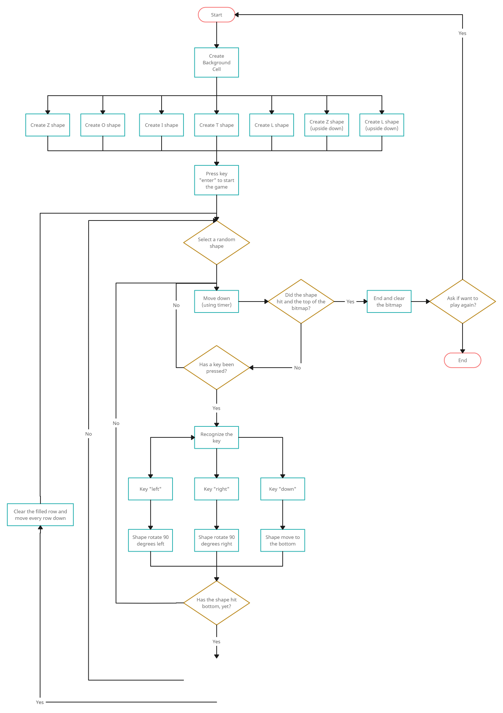

Has a row of cells being filled completely?

**4.Data Dictionary**

|  |  |  |  |  |  |  |  |
| --- | --- | --- | --- | --- | --- | --- | --- |
| **Sr.no** | **Column** | **Data type** | **Size** | **KEY** | **Constrain** | **Description** | **example** |
| 1 | Player_id | Int | - | PK | Al | Primary key of table | 1 |
| 2 | First_name | Varchar | 20 |  | Not Null | First name of user | James |
| 3 | Last_name | Varchar | 20 |  | Not Null | Last name of user | Bond |
| 4 | Contact_no | Varchar | 13 |  | Not Null | Contact Number with Country Code | +91 9876543210 |
| 5 | Email | Varchar | 30 |  | Not Null | Email of player | James123@gmail.com |
| 6 | User_name | Varchar | 20 |  | Not Null | User Name | champion |
| 7 | Password | Varchar | 10 |  | Not Null | Password | ****** |

**5.Data Flow Diagram (All Levels of DFDs)**

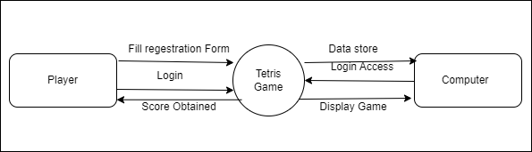

**5.1DFD Level 1 Diagram**

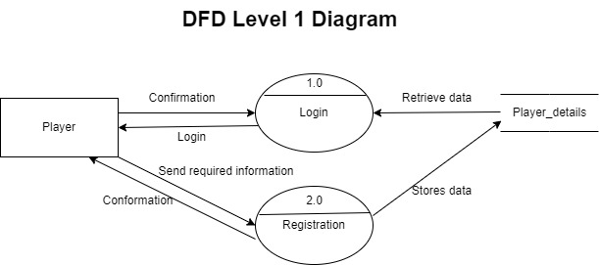

**5.2DFD Level 2 Diagram**

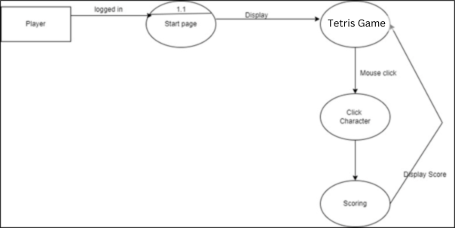

**5.3Data Flow Diagram level 2**

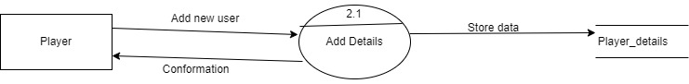

**6.Use Case Diagram**

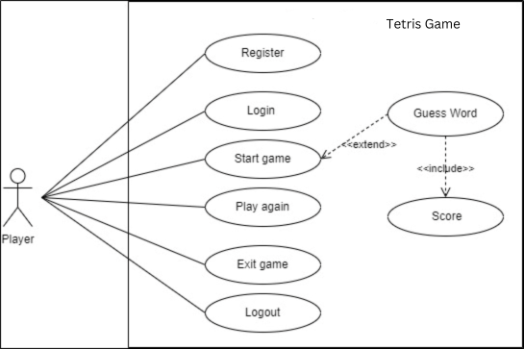

Row filles

**8.ER Diagram**

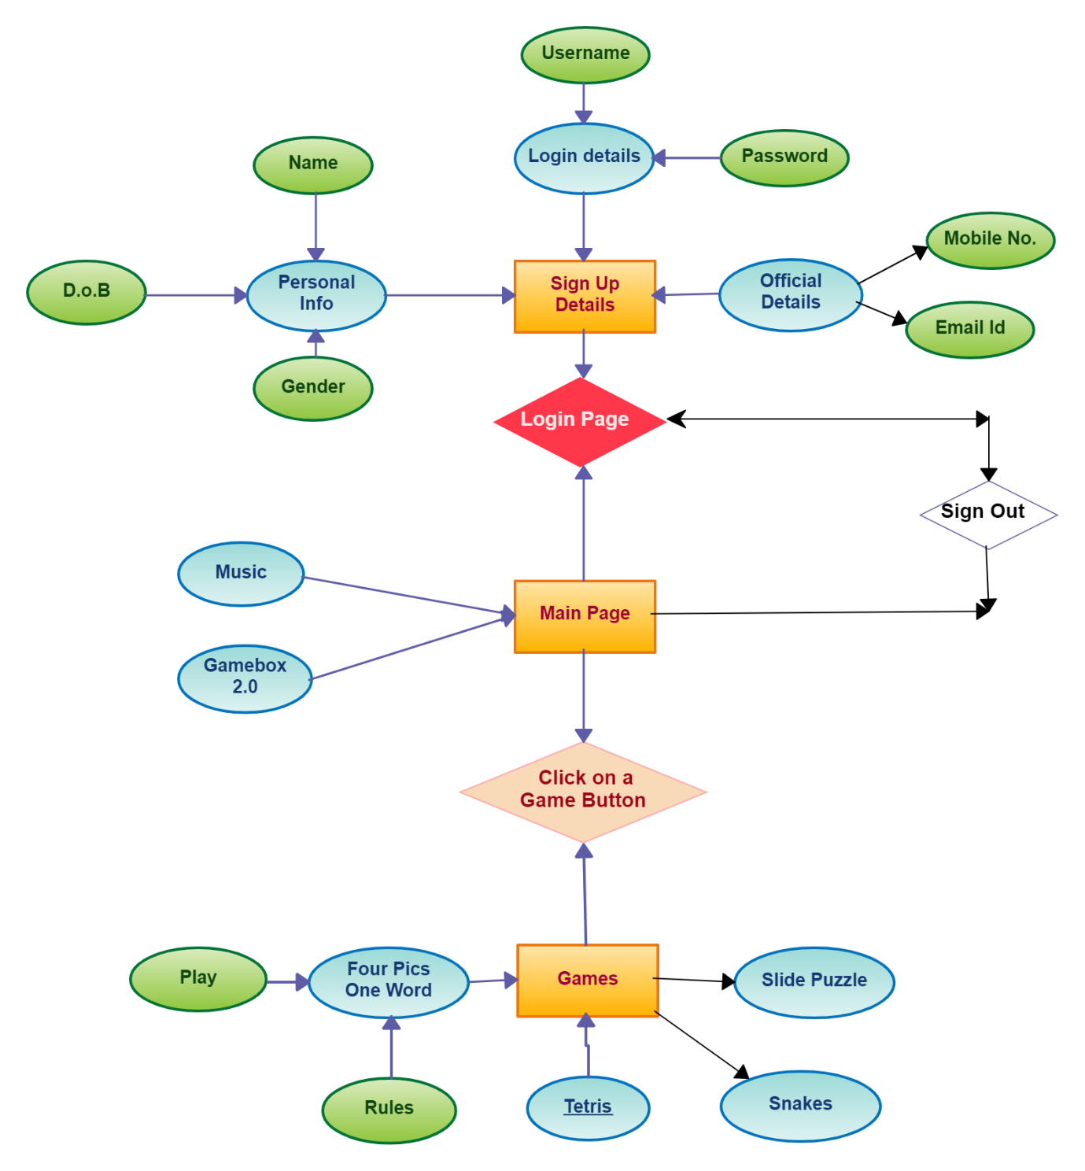

Class Diagram

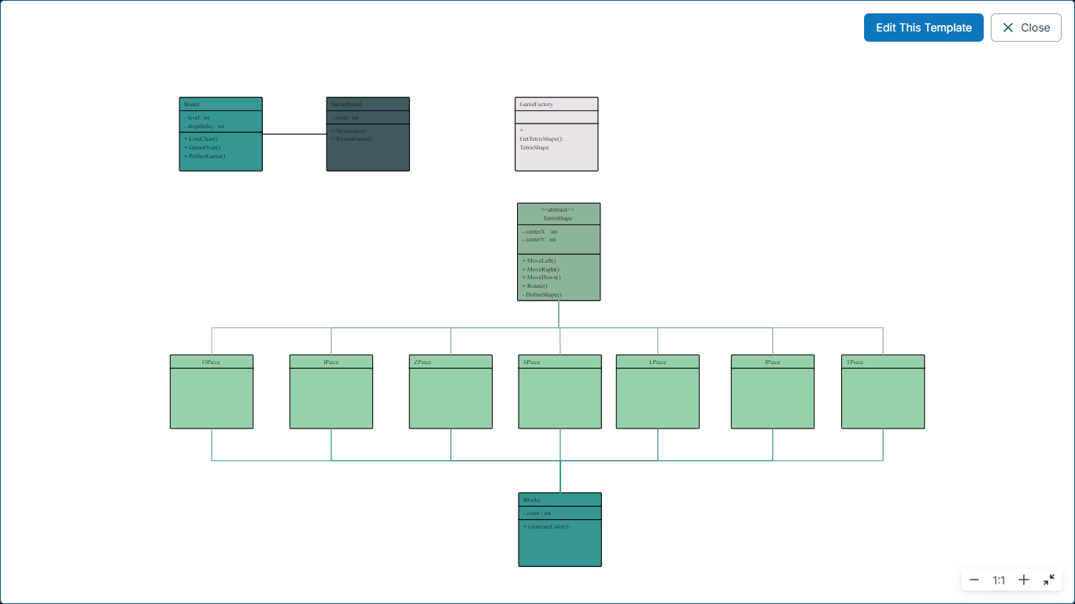

Activity Diagram

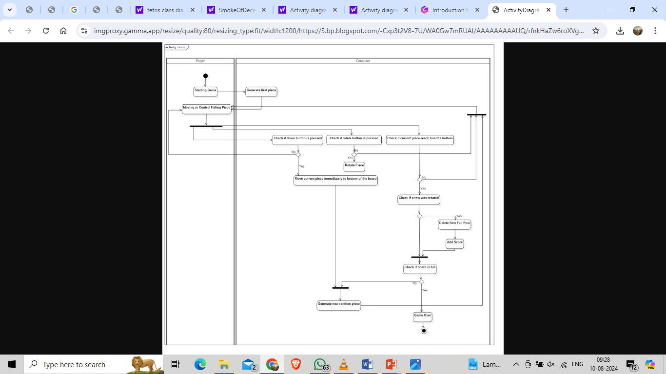

**9.Screenshots of Development Phase -1**

**9.1 Login and registration page**

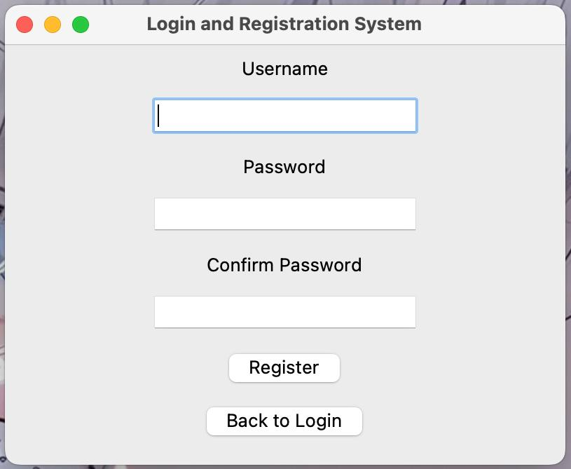

**9.2 Login page**

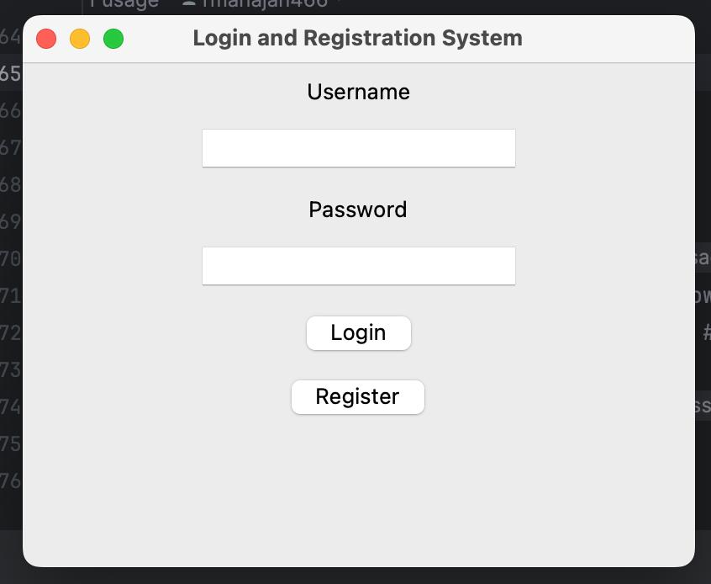

9.3 Game Page

